Seven Seas Mariner
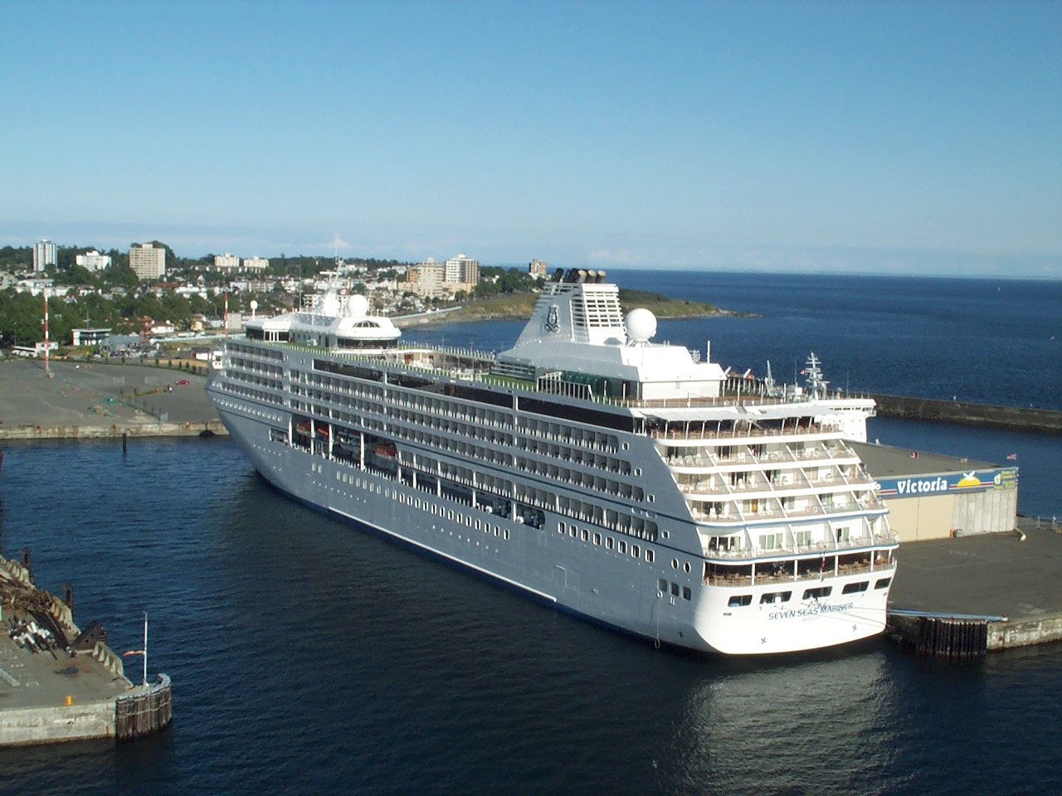
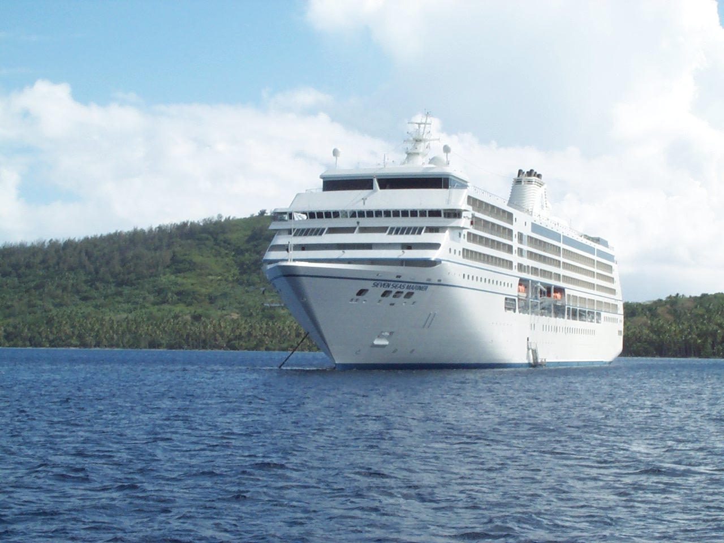
- Year of commissioning: 2001
- built by Chantiers de l'Atlantique in Saint-Nazaire, France
- design inspired by the Mistral.
- Flag: Mata Utu in the Polynesian customary kingdoms, now Nassau, Bahamas
- Speed: 20.00 knots
- Gross tonnage: 48,075 UMS
- Displacement: 4700 tonnes
- Number of passengers: 700
- Crew: 440
- Length: 216 metres
- Width: 28 metres
- Draught: 6.00 metres
- Number of decks: 8
- Propulsion and steering: 2 x 8500 kW Rolls Royce Mermaid azimuth pods developed by Kamewa and Alstom.
- Power generation: 4 x 7920 kW Wärtsilä 12V38A generators.
- IMO number: 9210139
See also fiche sea and marine boat
see the photo gallery

back to CV summary page

