Career path

Navigation on merchant ships (2003-2010)
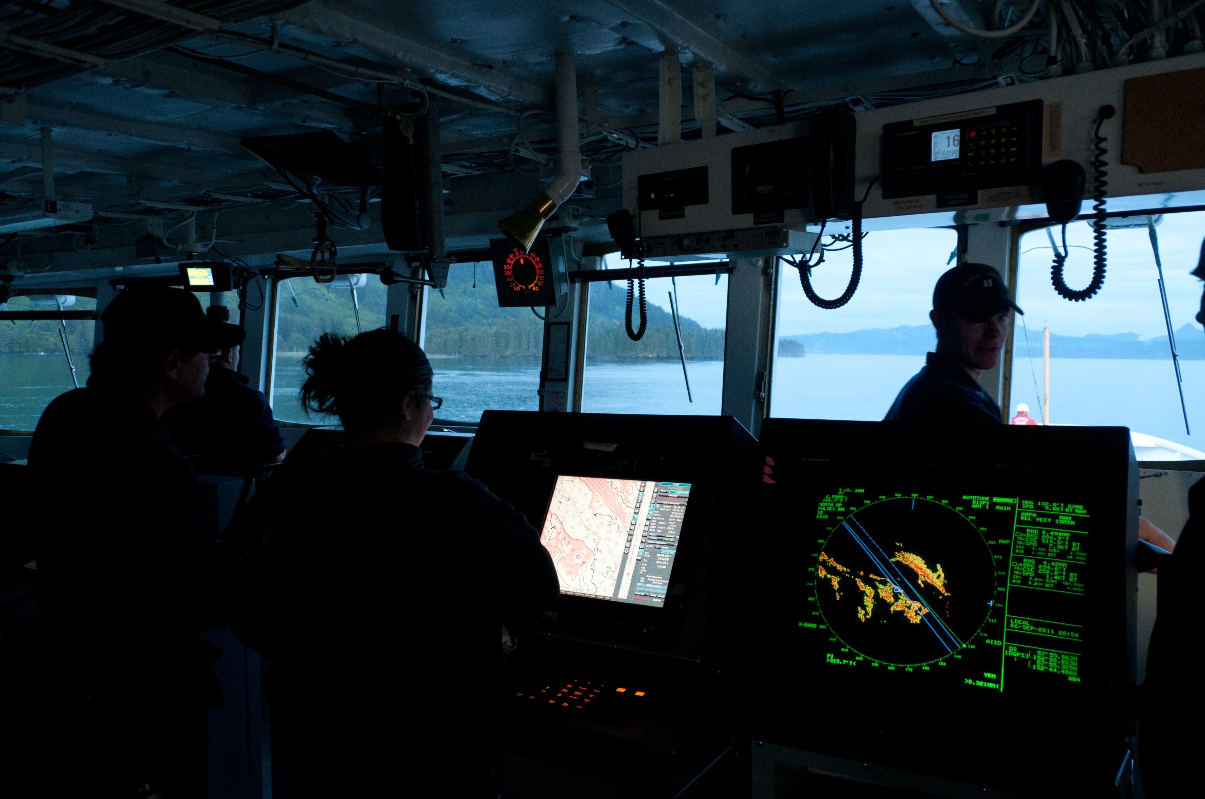
Sailing on cargo ships is extremely instructive. You learn to take responsibility right from the start. There's a strong sense of hierarchy, but that doesn't mean you don't have a great deal of autonomy when it comes to your tasks. At sea, there's no garage, no fire brigade and no doctor: a crew has to make do with what's on board! Finally, I'd like to add that you have to enjoy working in a team and, beyond that, living in a community.
During Boarding, I mainly sailed as a deck or engine watch officer.

Manager in river and maritime shipping companies ( 2010-2019 )
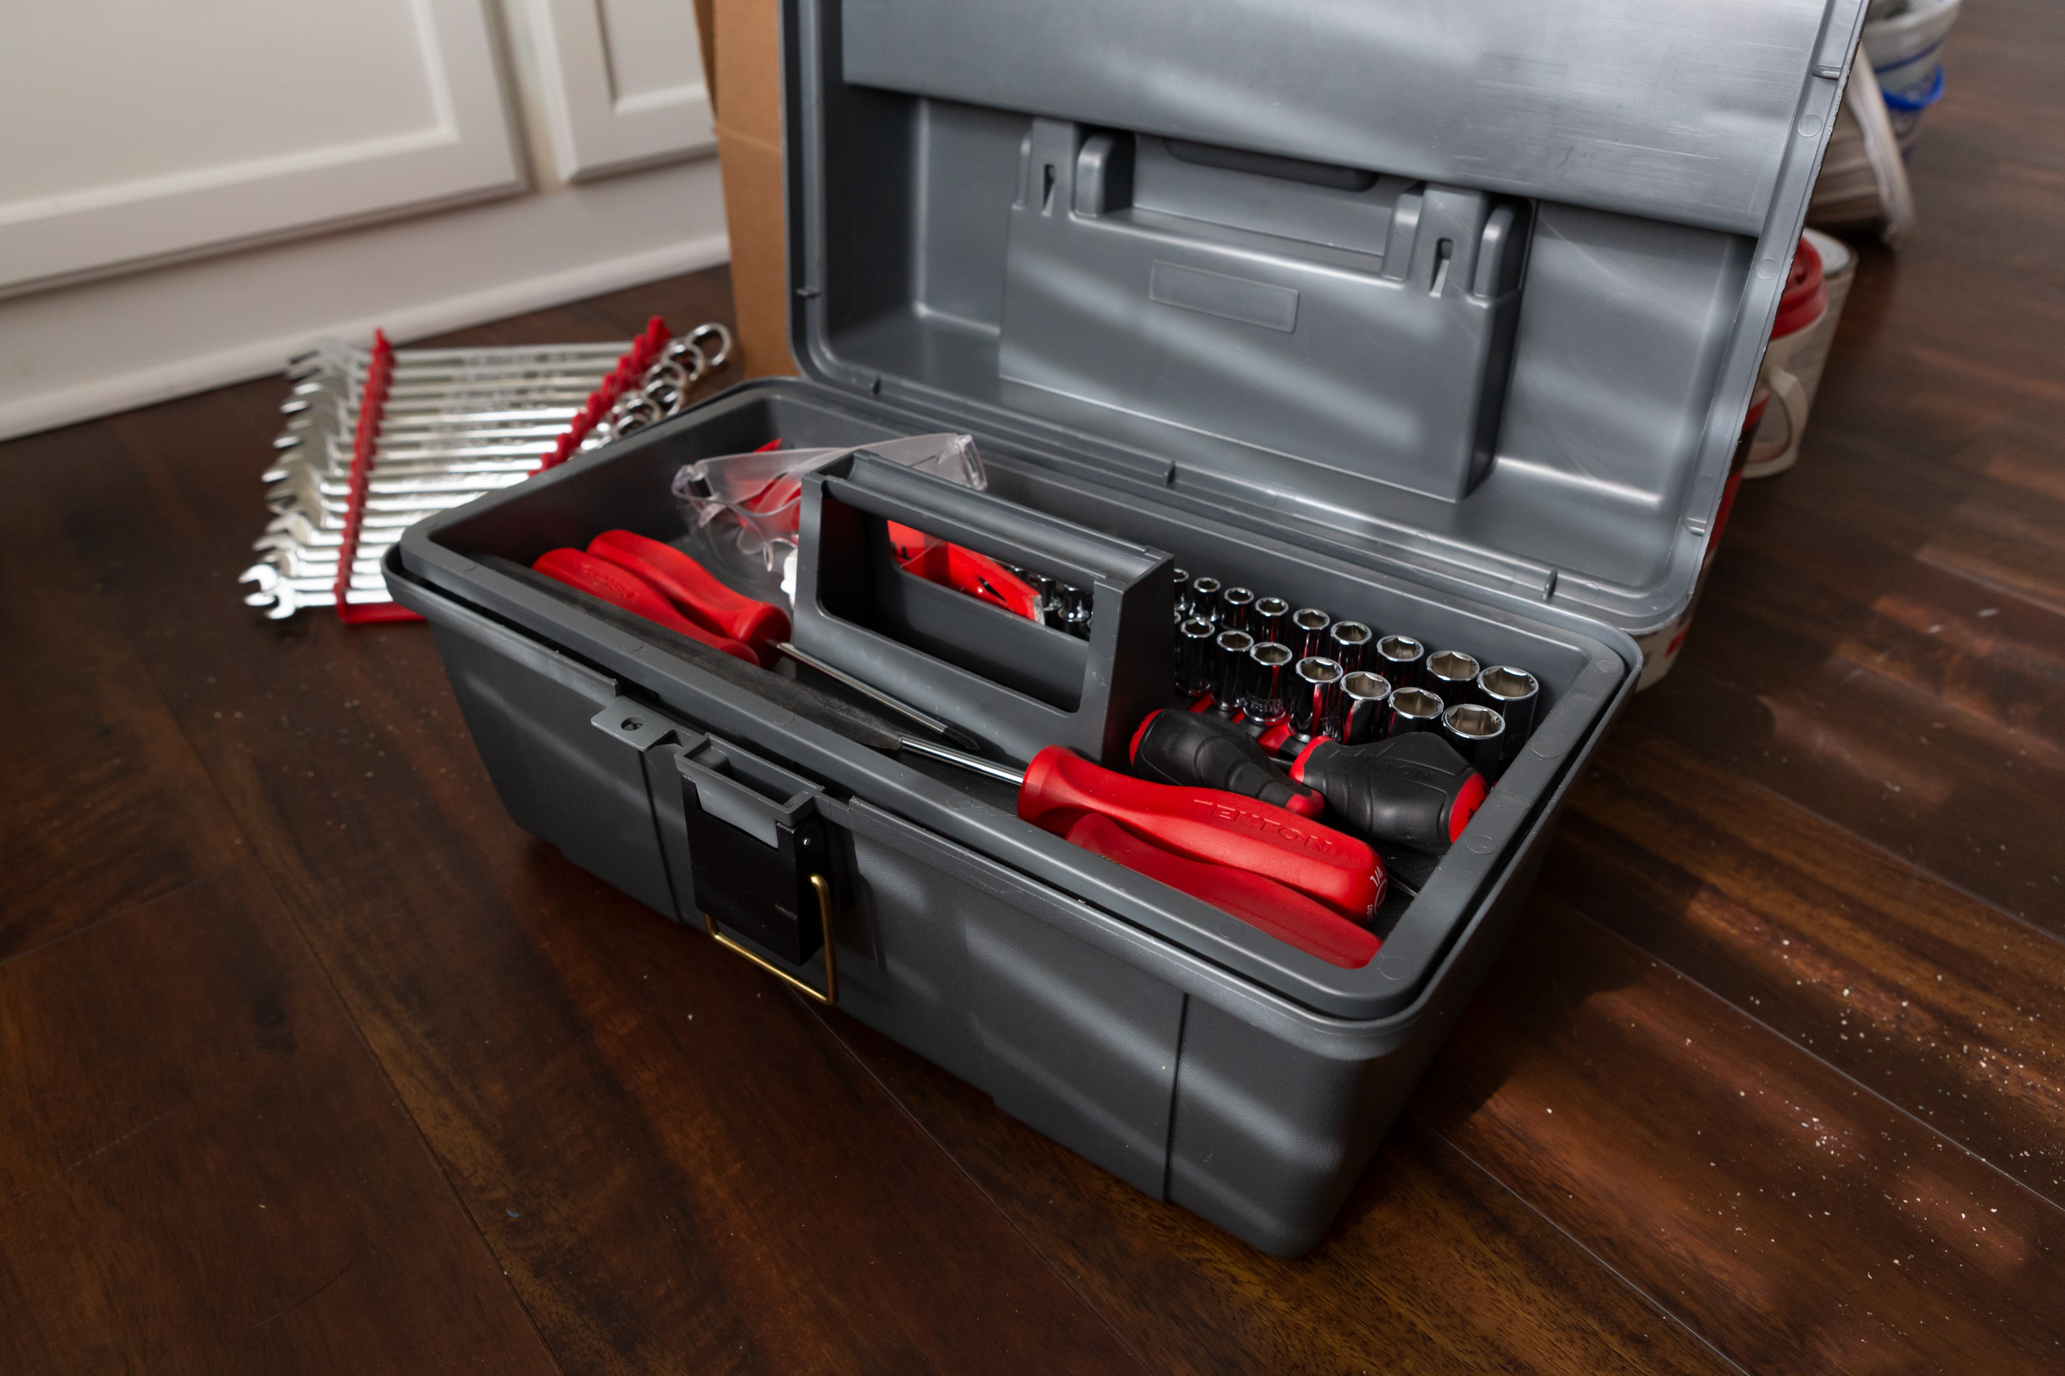
- 2010-2014 Technical Manager at Fluviofeeder Armemement. Responsibility and the freedom to make decisions made me decide to stay and take up the daily challenges.
- 2016 Responsible for certification of the mixed ferry Kreiz for the Comoros, diagnosing the state of seaworthiness. Relations between the shipyard and the certification class, or how to strike a balance between Africa's limited resources and the requirements of the French authorities.
- 2017-2019 Operations Manager CBL: Compagnie des Bacs de Loire Fleet of 3 ferries, 24 sailors. Management of the technical side and certification of the vessels. Crew management. Once again, I've been given a lot of confidence, so I'm fully committed to this adventure.

Trainer (2021- today)
- 2021-2022 Trainer at the Lycée Professionnel Maritime in Nantes
- 2023 Remote trainer from Serbia: help in preparing for competitive exams, technical assistance and professional follow-up for former students, translation of technical texts into French.
- 2023 French trainer: courses for Serbians wishing to pass level C1. Conversation and correction of texts.
- 2024-2025 Electrical engineering and automation teacher at the maritime vocational school until February 2025.
- February 2025 Job search in Serbia following a family move.

Various experiences
- summer job
  - 1998 clerk in a traditional bakery and pastry shop.
  - 1999 work in a slaughterhouse, making sandwiches, delivering drinks.
  - 2000 waiter in a bar-restaurant; dishwasher in Jersey.
- 2015: an audit assignment auditor at PNS: Piriou Naval Service. discovery of fishing boat maintenance.
- 2020: management of the family's agricultural assets - technical, human and legal issues.
- 2020 to date: Dokuwiki software trainer.

