Unlimited Dual Officer Training Program
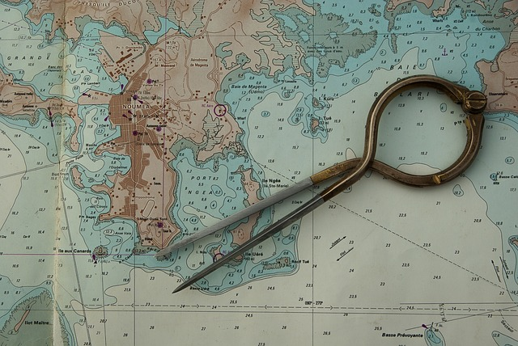
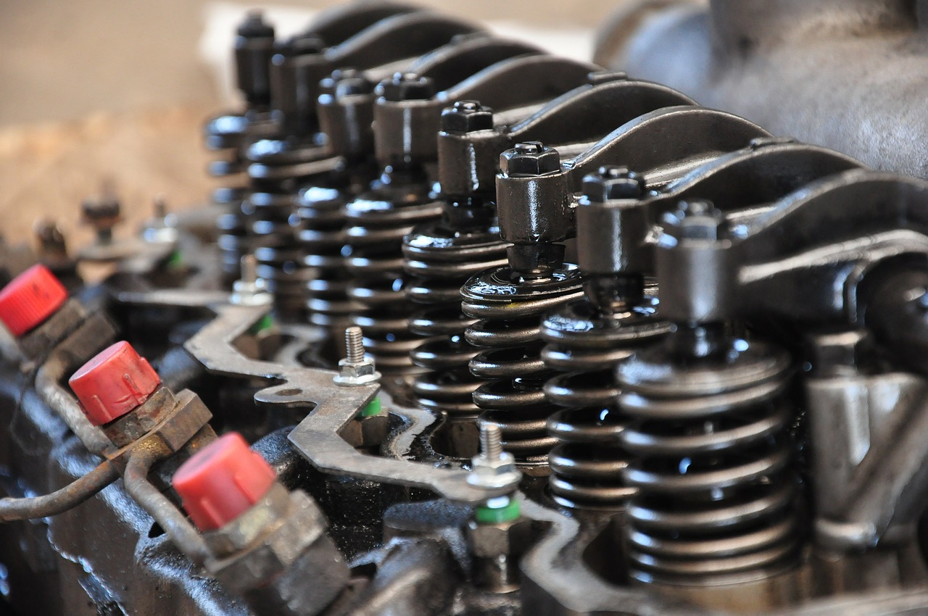

Summary
This training provides the highest possible qualification in the merchant navy, both in deck and engine departments. Graduates are thus eligible to work on all types and sizes of civilian ships. The courses provide comprehensive knowledge and operational skills for future Deck Officers and Engine Officers, with no tonnage or power limitations. This is why the training is called “unlimited and dual-purpose”.
After a scientific baccalaureate, I completed four years of study and one year of internship at the French National Maritime Academy in Marseille (ENSM).
Last diploma obtained: DESMM (equivalent to Master's level – EQF Level 7).
NB: For information on other maritime training programs, see the website of the French Institute of the Sea

The French National Maritime Academy
The ENMM was formerly called the “Hydrographic School”, which earned it the nickname “Hydro”. Today, it has been renamed ENSM – École Nationale Supérieure Maritime (school website).

3 Years of School
1999: Obtained the scientific baccalaureate and passed the competitive exam for entry into the 1st class merchant navy officer program.
1999–2002: Training completed at the ENMM Marseille (see description of the officer training program by the school)
2002: Diploma of Cadet Officer – 1st Class Merchant Navy, including:
First aid training
Firefighting techniques training
General Operator Certificate (GOC – GMDSS)
Survival Craft and Rescue Boats certificate (BAEERS)
See also the school flyer.

12-Month Internship as Cadet
As a cadet:
- CMA-CGM container ship Douce France – First experience of navigation
- Cruise ship Seven Seas Mariner – Training in a stimulating environment
- Scientific research vessel L'Atalante
These internships led to the issuance by the maritime administration of the Unlimited Watchkeeping Certificate (Deck and Engine), allowing me to start my career as Third Officer.

Final Year of School
2005/2006: Final academic year at ENMM Marseille.
2006: Diploma of Advanced Studies in the Merchant Navy (DESMM)
Final thesis: How to reduce operational pollution from ships.

Summary of Diplomas and Certificates
*
Diplomas:
- Cadet Officer – 1st Class Merchant Navy (2002)
- Advanced Studies in the Merchant Navy – DESMM (2006), equivalent to a Master’s degree (Master 2)
Certificates:
- Survival Craft and Rescue Boats (BAEERS) and fast rescue training
- Ro-ro vessel safety certificates
- General Operator Certificate (GOC – GMDSS)
- Basic and advanced medical training onboard
- Basic and advanced firefighting (CFBLI & CQALI)
- Radar and ARPA
- Ship Security Officer (SSO)
- Designated Person Ashore – ISM (International Safety Management)
- Internal ISM Auditor
Certificates of Competency:
- Unlimited Officer of the Watch – Deck and Engine
- Unlimited Second Officer
- Unlimited Second Engineer
NB: A Certificate of Competency in the merchant navy requires both the corresponding academic diploma and a certain amount of sea time in the required role.
Back to CV summary page

